UNION & UNION ALL EXERCIZE

Senzekile Ayanda Nsimbi
Student no : 2805001628
13 JUNE 2026

SECTION 1: UNION
QUESTION 1
I’ve provided 2 answers for this question, 1 with City (returns duplicates) and 1 without City ( returns no duplicates)

Question 1 – Answer 1
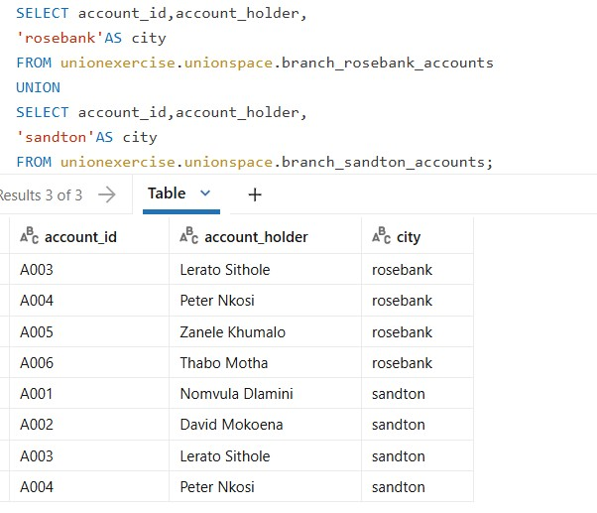
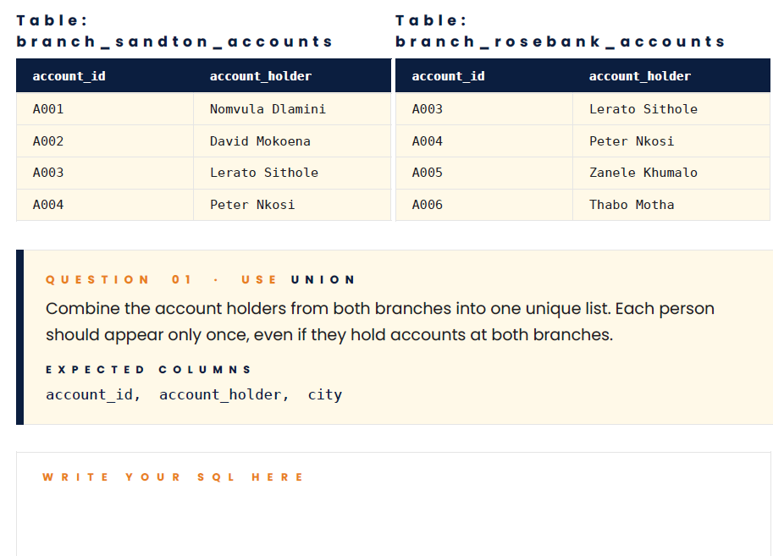

Question 1 - Answer 2:
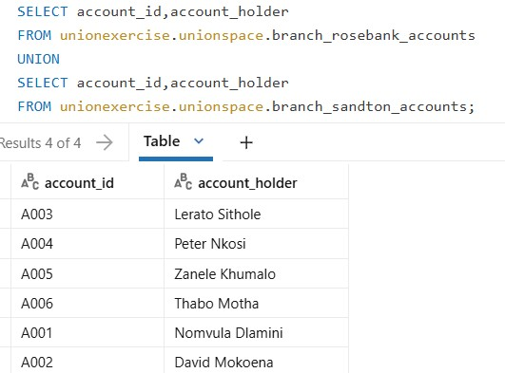

QUESTION 2
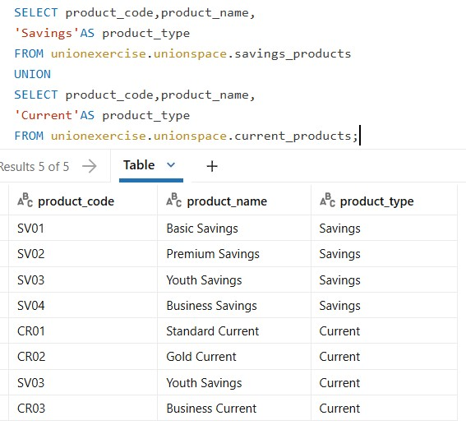
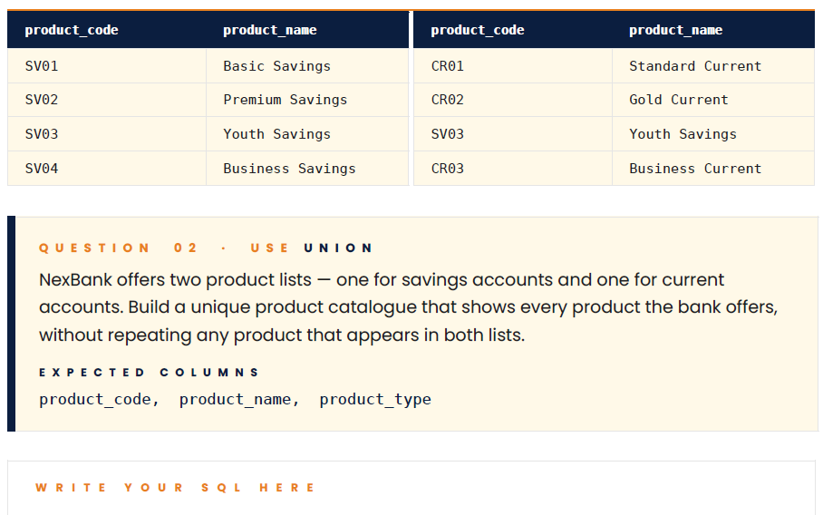

QUESTION 3
This question requires an additional column of email , however there’s no ‘email ‘ data given , therefore I used NULL for the Email column
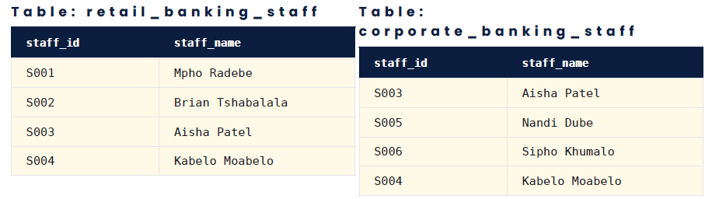
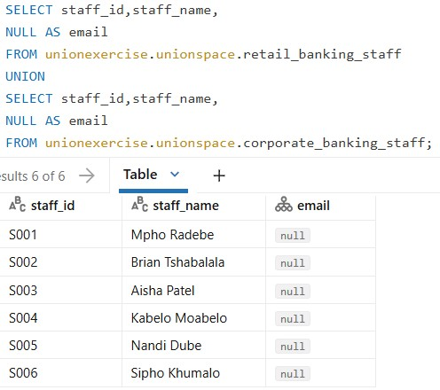
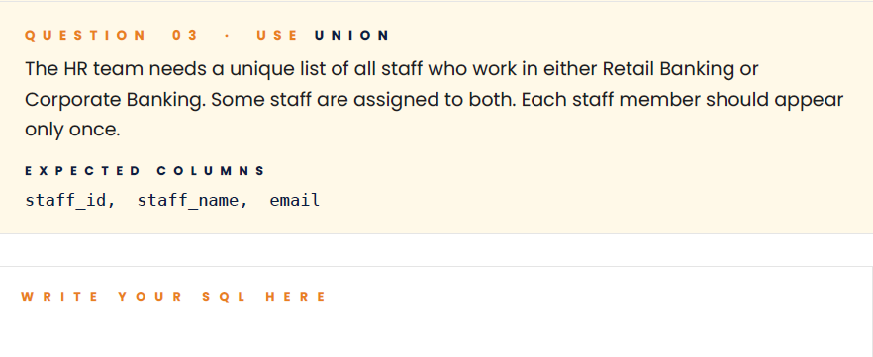

QUESTION 4
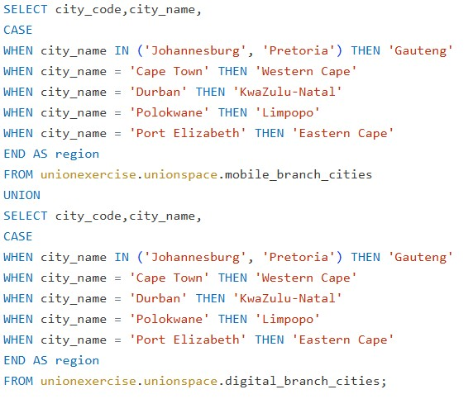
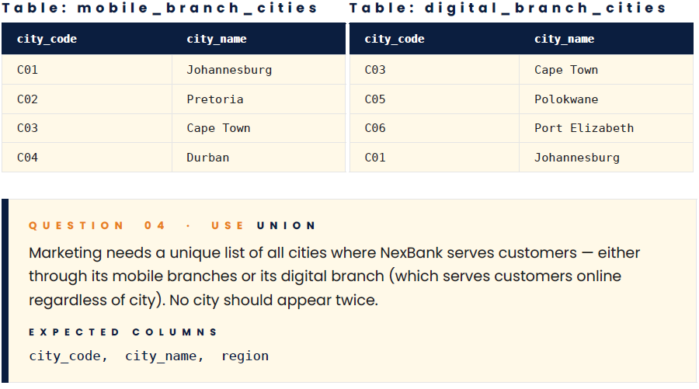

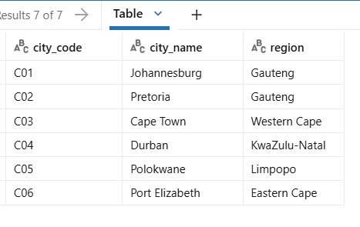

QUESTION 5
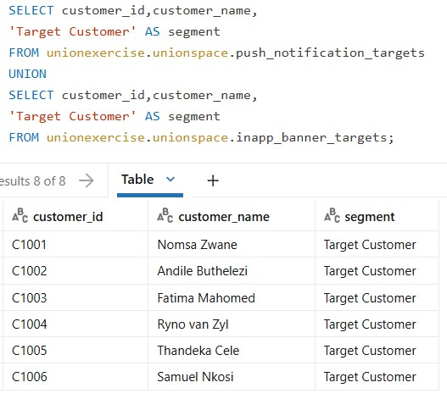


SECTION 2 - UNION ALL
QUESTION 6
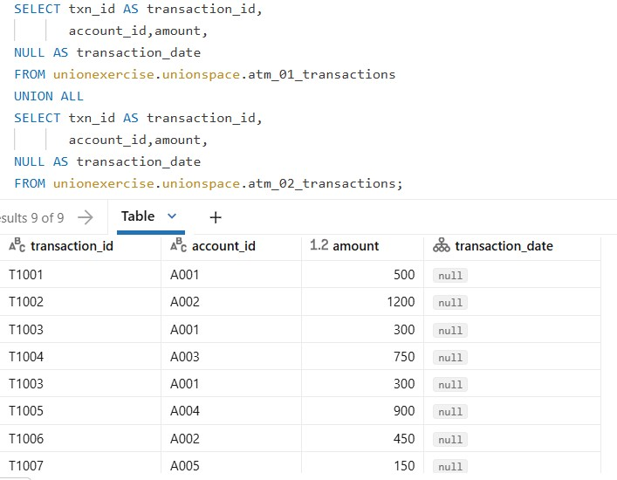
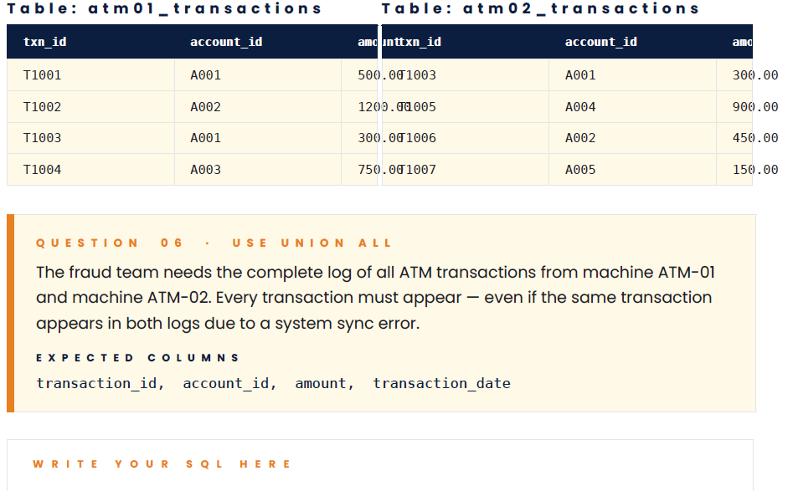

QUESTION 7
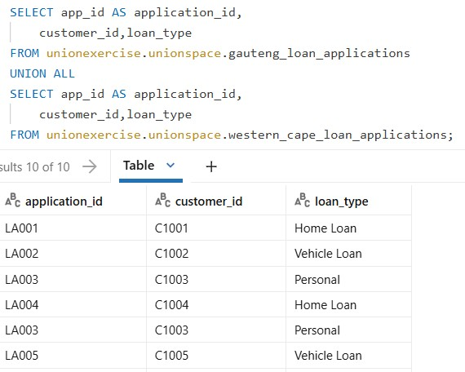
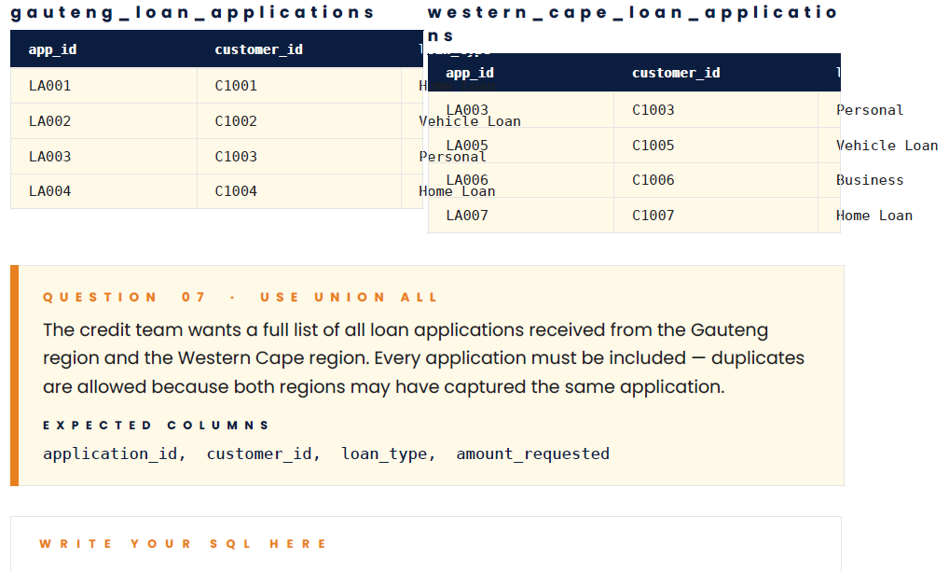

QUESTION 8
Theres no logged date info given , therefore used NULL
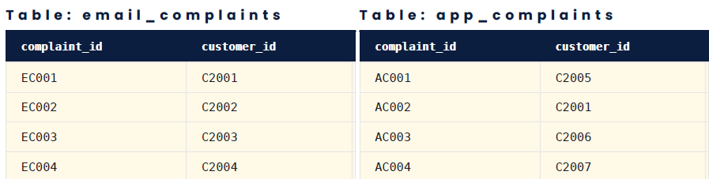
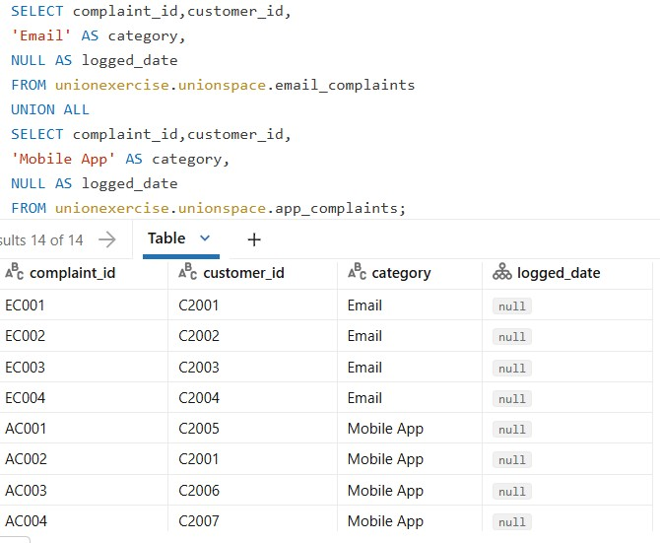
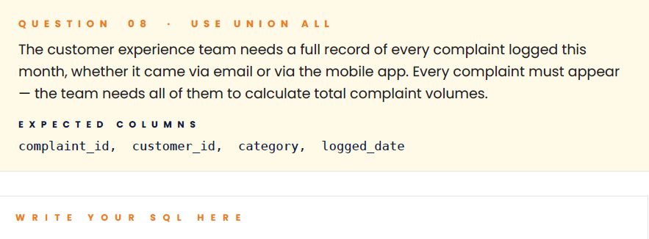

QUESTION 9
No payment date given, used NULL
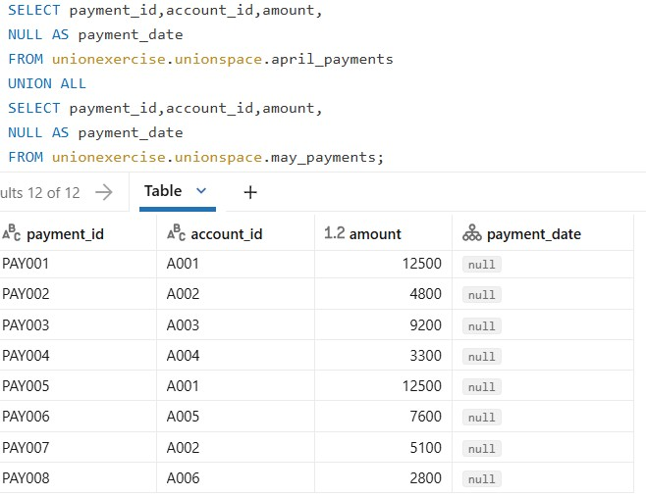
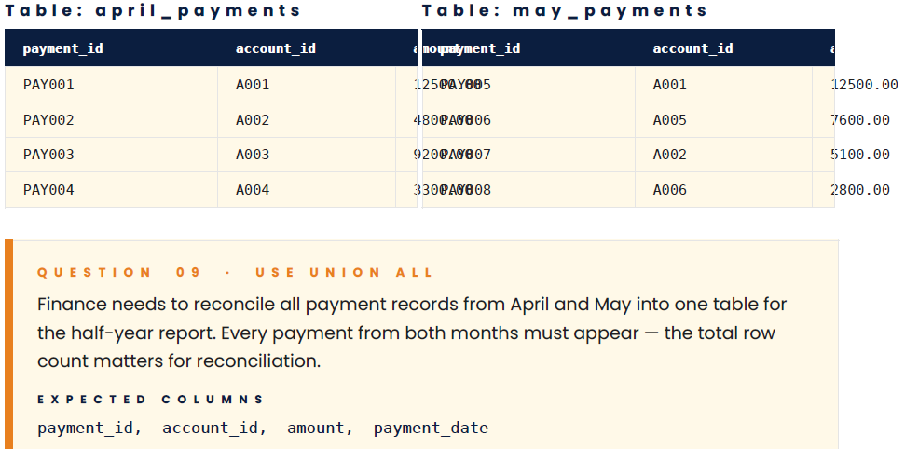

QUESTION 10
No Amount and Entry date data given , NULL function has been used to create expected columns
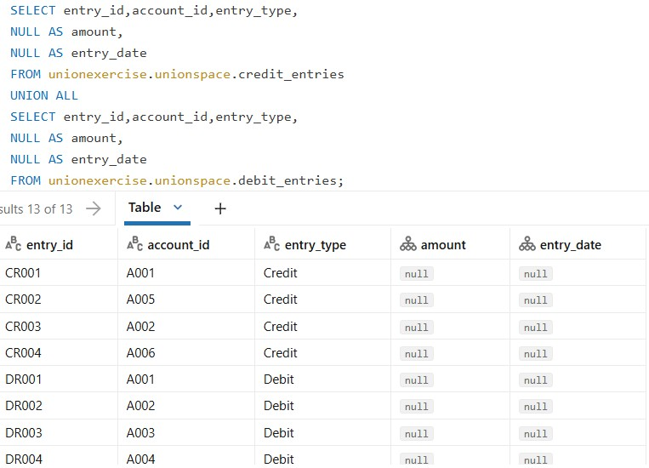
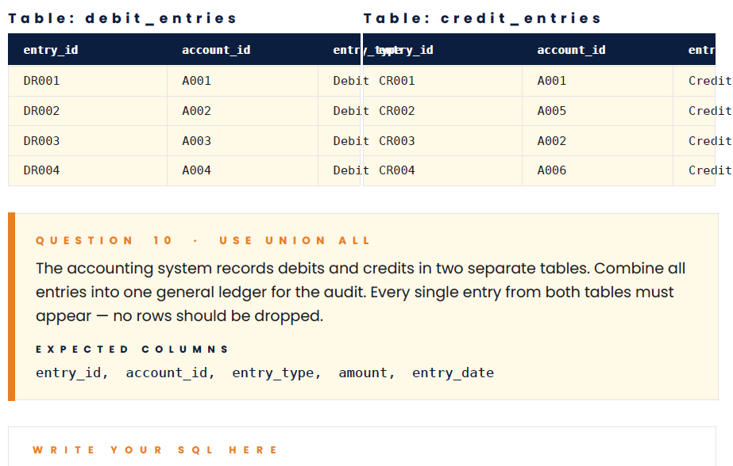

SECTION 3 – BONUS QUESTIONS
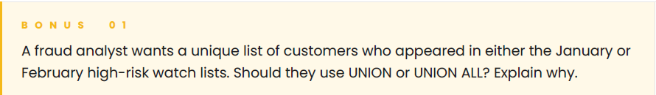
- UNION, this will eliminate duplicates and narrow the list down, all high risk customer will still appear.

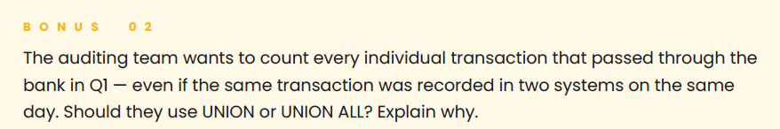
- UNION ALL, this will pull off the records from both systems, no records should be eliminated for this individual count.


- The query fails because of `city` which is mentioned on the second SELECT statement, to get correct outcome, the SELECT statements must be the same:

SELECT account_id, account_holder
FROM branch_sandton_accounts
UNION
SELECT account_id,account_holder
FROM branch_rosebank_accounts;

OR

SELECT account_id,account_holder,city
FROM branch_sandton_accounts
UNION
SELECT account_id,account_holder,city
FROM branch_rosebank_accounts;

